Algebra 1: Unit 9, Lesson 3

- The table of values of a quadratic function is shown.
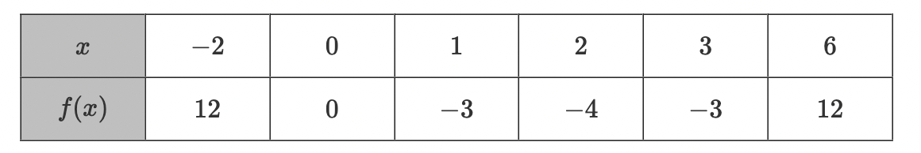
Determine the vertex of the function.
$$(2,-4)$$

- The table of values for a quadratic function, $f(x)$ is shown.
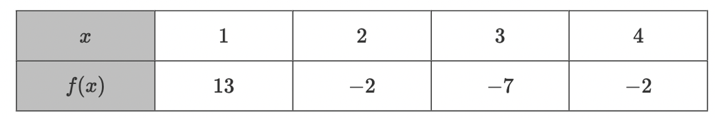
Arianna partially completes writing the vertex form of the function as $f(x)=5{(x-h)}^{2}+k$. Rewrite the quadratic function in vertex form using the vertex.
$$f\left(x\right)=5{\left(x-3\right)}^{2}-7$$

- The table of values of a quadratic function is provided.
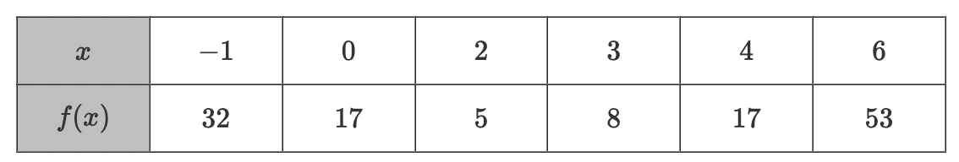
Melissa determined that the vertex of the quadratic function is $(2, 5).$ She used the point, $(-1, 32)$ to write the vertex form of the function equation.
$$32=a{(-1-2)}^{2}+5$$
What is the value of $a$?
$$3$$

